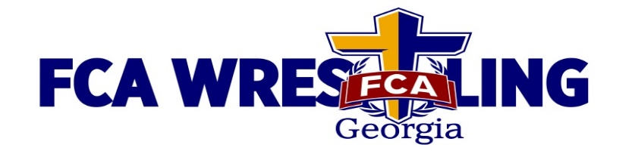

TEAM WRESTLING CAMP
June 3 – 6, 2024
Emmanuel University in Franklin Springs, GA

Format: The camp is a 3 night/ 4 day camp: world class clinicians, tough competition, & an awesome FCA inspirational program. (Open to M.S. through H.S. wrestlers.)

Clinicians:
Jim Gruenwald (3x National Christian College Champ; 4x National AAU Greco Champ,
2x Olympian for USA; Pan Am Champ & World Cup Champion; Coach at Wheaton College).
Tom Ryan (2x NCAA All-American for U. of Iowa; Head Coach at perennial BIG TEN powerhouse Ohio State; 3x “NCAA Coach of the Year”). Omi Acosta (Coach at Life University – 2021 NAIA National Champs & 2022 National Runner-ups; 2021 NWCA’S National Coach of the Year for NAIA; 2021 USA Wrestling Magazine’s National Coach of the Year. Has produced 5 NAIA National Champs,14 National finalists, 31 All-Americans, & 55 National qualifiers. Bryce Killian (Coach at Emmanuel University, 2x Division II All-American, & Academic All-American). Ben Smith (Former wrestler @ UT-Chattanooga; Former Head Coach for highly successful program at Bradley Central HS in Tennessee).
Jeff Bedard (2x All-American & NAIA National Champ for Carson-Newman; Was a 3x U.S. Armed Forces Champion for the U.S. Army; a Military World Champion & 6x US Open All-American; Georgia Coach of the Year in 2007 while coaching Wesleyan to a state championship. As a club coach, Jeff has helped develop 54 H.S. All-Americans & 37 state champs. Now Coach of Reinhardt U., where he was the NAIA’s 2019 National Coach of the Year. In the college ranks, Jeff has produced 27 All-Americans and 2 National Champs).
Mike McArthur (A coach and minister to numerous young men, from youth wrestlers to "World Class" athletes. As a competitor, Mike was a 2x State Champion, a 2x All-American, placing second and third in the NCAA D-I national tournament for the University of Minnesota, 3x Midlands Champion, 1976 Olympic Team Alternate for the United States Freestyle Team for the Montreal, Canada Olympic Games)

Cost: Discount price: $415.00/ wrestler, if registered by 5/20/24.
Price increases to $435/ wrestler after 5/20/24.
Prices apply to teams & individuals: Includes 3 nights lodging, 4 days of great technique training & competition, 9 meals, T-shirt, & FCA Bible.
***(1 coach free for every 10 wrestlers)***

(There will be a LIMIT on the number of teams & wrestlers at this camp.)
(Wrestlers registering individually must have $75.00 deposit in by same date.)

**Information for securing camp scholarships is on our website, noted below. **

For more information, or to register for camp, visit our website, at www.fcawrestlinggeorgia.org

Contact:
FCA Wrestling Georgia • Trevor Ramos • 470-480-6174 • tramos@fca.org

